**MINISTRY OF EDUCATION AND TRAINING**



**Capstone Project Document**

**Hotel Website**

**Introduction**

**Project Code: HOWE**

**Document Code: HOWE_INT – v1.0**

Hoalac, May 22nd, 2017

Contents

1. PURPOSE　目的 3

2. PROJECT INFORMATION　プロジェクトの情報 3

3. PROJECT MEMBERS プロジェクトメンバー 3

4. OUR PROPOSAL 提案 4

4.1 Problem 問題 4

4.2 Solution 解法 4

4.3 Idea アイディア 4

5. LITERATURE REVIEW OF EXISTING WEBSITES 4

5.1 Kim Lien Hotel キムリエンホテル 5

5.2 Hilton Hotel　ヒルトンホテル 6

5.3 Comparison 6

6. PRODUCT　商品 7

7. BENEFIT FROM PROJECT プロジェクトからベネフィット 8

7.1 For our group グループのために 8

7.2 For user ユーザーのために 8

# PURPOSE　目的

This chapter provides an overview of Hotel Website, it includes background information and literature review of existing system.

# PROJECT INFORMATION　プロジェクトの情報

|  |  |
| --- | --- |
| Project name: | Hotel Website |
| Project code: | HOWE |
| Project type: | Website |
| Project category: | New development |
| Business type: | Business |
| Project manager: | Nguyen Viet Hung |
| Timeline: | May 8th,2017 to August 26th,2017 |

Table 1.2 – Project Information

# PROJECT MEMBERS プロジェクトメンバー

* Supervisor:

|  |  |  |
| --- | --- | --- |
| Full name | E-mail | Title |
| Phan Truong Lam | [Lampt2@fe.edu.vn](mailto:Lampt2@fe.edu.vn) | Lecturer |

* Team members:

|  |  |  |  |  |
| --- | --- | --- | --- | --- |
| Full name | Roll number | E-mail | Phone | Position |
| Nguyen Viet Hung | SE03577 | [hungnvse03577@fpt.edu.vn](mailto:hungnvse03577@fpt.edu.vn) | 01648172064 | Leader |
| Vu Tran Hoang | SE03931 | [hoangvtse03931@fpt.edu.vn](mailto:hoangvtse03931@fpt.edu.vn) | 096.296.2174 | Member |
| Dang Cong Son | SE03564 | [sondcse03564@fpt.edu.vn](mailto:sondcse03564@fpt.edu.vn) | 0129 639 6358 | Member |
| Dang Duc Manh | SE03539 | [manhddse03539@fpt.edu.vn](mailto:manhddse03539@fpt.edu.vn) | 01662451994 | Member |
| Tran Ba Quyen | SE02724 | [quyentbse02724@fpt.edu.vn](mailto:quyentbse02724@fpt.edu.vn) | 01636969459 | Member |

# OUR PROPOSAL 提案

## Problem 問題

Vietnam, with 8 world heritage sites, 11 intangible cultural heritages, traditional customs maintaining the national identity, and thousands of resorts and tourist destinations has been attracting millions of local and foreign tourists every year. The higher the number of tourists is, the greater the demand for accommodation and hotel services increases, resulting in the establishment of more hotels.

In fact, a hotel in Halong just has ordered project team a website aimed at promoting the image and facilitating online hotel reservations base on an existing website. However, after discussion, the team founded that the current system does not meet the requirements of that hotel’s business. In addition, the booking process of not only this website but also many similar one are too complex that caused many obstacles to the customers.

## Solution 解法

Together with the customer solve the problem to meet the condition and requirements of the hotel. Simplify but maintain the effectiveness of the process of looking for accommodation and booking.

## Idea アイディア

Design a website meeting all requirements, including heavily promoting the hotel’s image, offering customers with a time-saving and efficient booking service, and providing favorable conditions for the hotel management in the near future.

# LITERATURE REVIEW OF EXISTING WEBSITES

In this section we will describe some three-stars hotel’s website respectively corresponding such as:

Kim Lien Hotel: <http://www.kimlientourism.com.vn/>

Hilton hotel: <http://www3.hilton.com/en/index.html>

## Kim Lien Hotel キムリエンホテル

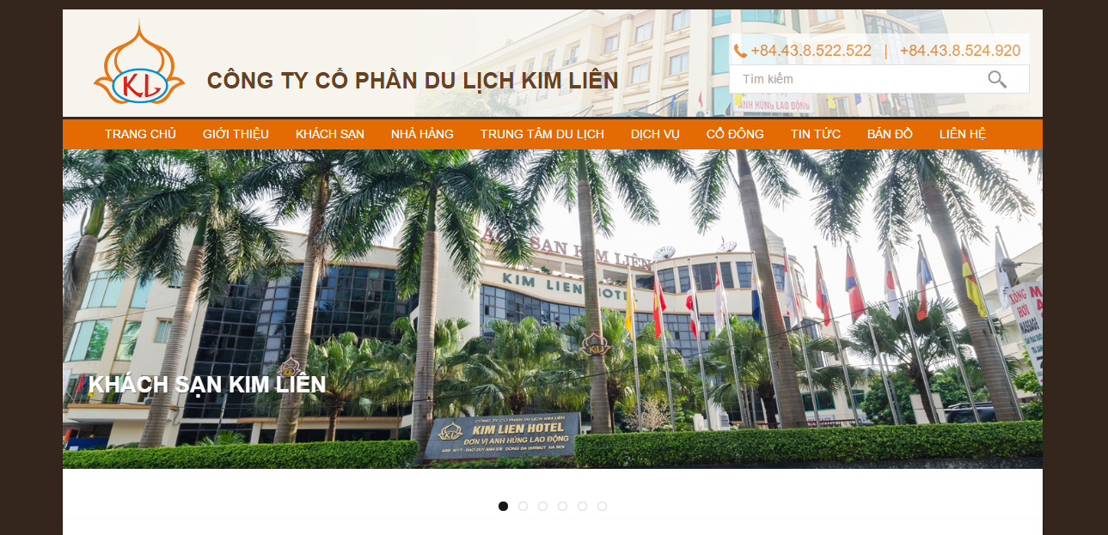

User interface design simple, friendly. Provide quite enough information about the hotel for guests

* “GIỚI THIỆU”: hotel profiles
* “KHÁCH SẠN”: information on facilities, rooms of the hotel, price
* “NHÀ HÀNG”, “TRUNG TÂM DU LỊCH”, “DỊCH VỤ”
* “CỔ ĐÔNG”: information on the operating apparatus, hotel management activities
* “TIN TỨC”, “BẢN ĐỒ”, “LIÊN HỆ”

However, the online booking function of hotel has not really optimized, many inadequacies and the implementation process is quite complex. Searching room information is not checked before execution, guests can not see basic information about rooms that can be booked.

## Hilton Hotel　ヒルトンホテル

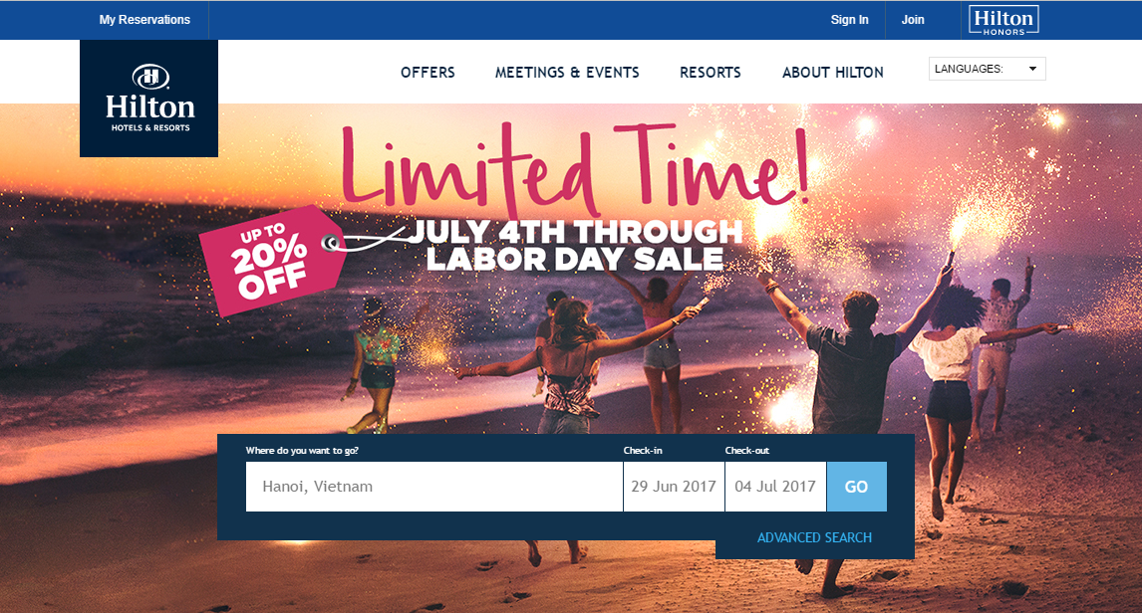

Website of Hilton hotel is designed simple, beautiful. That also provide basically information such as:

* Offers: providing for guests with special service packages
* Meetings & events: information for conferences, events featured in the hotel
* Resorts: information for resorts of hotel
* About Hilton: hotel profiles
* My reservation: search, change information of myself reservation

The online booking function of hotel is quite complete compared to Kim Lien hotel, but like Kim Lien, the online booking process is still complicated through many steps to complete the reservation

## Comparison 比較

This section will list some of the comparison criteria for HOWE with Kim Lien and Hilton hotel, which are built on the guest’s perspective of the system

|  |  |  |  |
| --- | --- | --- | --- |
| Tiêu chí đánh giá | HOWE | Kim Lien Hotel | Hilton Hotel |
| Ease of use of the website |  |  |  |
| Simple design of the website |  |  |  |
| The simplicity of the online booking room function |  |  |  |
| Provided information on the website |  |  |  |
| Multi languages |  |  |  |
| Online payment |  |  |  |

# PRODUCT　商品

Following the research on hotel’s business, the most important and necessary functions have been proposed. The operations will be simple and easy to understand, the interface will be neatly designed and friendly with users.

Basic Functions:

Guest

* Booking room
* Search room
* Sent feedback, Q&A
* View hotel page
* Cancel booking room

Receptionist

* View hotel page
* Change password
* Booking Room Management
* Check In
* Check Out
* Create bill

Manager

* Service management
* Page management
* Edit room’s detail
* Account management

Accounting

* Handover finance
* Search bill
* Monthly revenue report

# BENEFIT FROM PROJECT プロジェクトからベネフィット

## For our group グループのために

From this project, after working together to develop this product, we will get some benefits:

* Have more experience on developing software product, project management like how to create the plan for project, estimate resources for it and manage time, process, members and risk.
* Have knowledge about HTML, PHP, Laravel, Bootstap, Jquery, AngolaJS, etc and have a chance to apply those technologies on our project.
* Improve relationship between team members, know how to communicate with each other and make teamwork more effective.

## For user ユーザーのために

* Provide a completely website for customer’s hotel.
* Guests can easily book for room and hotel’s manager can easily manages booking information and guests.
* A website will be useful for hotel in advertising and attracting guests.